|  |  |
| --- | --- |
| C:\Users\Plasma-PC\Desktop\logo.jpg | **MINISTRY OF EDUCATION AND TRAINING** |

**FPT UNIVERSITY**

**Capstone Project Document**

**Olives**

Project Code: Olives  
Document Code: **Olives_PP_v1.0**

|  |  |  |
| --- | --- | --- |
| **Olives Team** | | |
| **Group member** | Phạm Đức Thắng | SE03055 |
| Trần Ánh Dương | SE02797 |
| Phạm Minh Tuấn | SE02875 |
| Bùi Quốc Trọng | SE03418 |
| Nguyễn Văn Hưng | SE02582 |
| Nguyễn Duy Linh | SE03150 |
| **Supervisor** | Lecturer: Phan Trường Lâm | |
| **Capstone Project code** | Olives | |

**Hoa Lac, 18th May 2016**

**CONTENT**

**1.** **Problem Definition** 2

1.1 Name of this Capstone Project 3

1.2 Problem Abstract 3

1.3 Project Overview 3

1.3.1 The Current System 3

1.3.2 The Proposed System 3

1.3.3 Boundaries of the System 3

1.3.4 Development Environment 3

**2.** **Project organization** 4

2.1 Software Process Model 4

2.2 Roles and Responsibilities 5

**3.** **Project Management Plan** 6

**3.1** **Task** 6

**3.2** **Project Schedule** 6

**3.3** **Meeting Minutes** 6

**4.** **Resource** 6

**5.** **Risk Management** 6

**6.** **Communication Management** 6

**9.** **Project Infrastructure** 8

9.1 Software and Techniques 8

9.2 Hardware 9

9.3 Other Infrastructure 9

**10.** **Coding convention** 9

**11.** **Version Numbering Rule** 9

**12.** **Directory Structure** 10

**13.** **Other Olives Rules** 11

1. Introduction

## Purpose

The purpose of MT Screen Design Document is to provide User Interface and Screen Flow of the project call Olives, which is an application that helps people take care your helps. Developer and tester will base on this design to implement and unit test.

## Definitions, Acronyms, and Abbreviations

|  |  |  |
| --- | --- | --- |
| Abbreviations | Description | Comment |
|  |  | Name of project |

## References

|  |  |
| --- | --- |
| Document Number | Title |
| 1 | Data design document |
| 2 | Architecture design document |

## Overview

This document include

* • Introduction of MT Project’s Screen Design.
* • Screen flow and some more detail description’s screen.

# 2. Screen Flow

## 2.1 Main Application

## 2.1.1 Sign In Your Account Screen

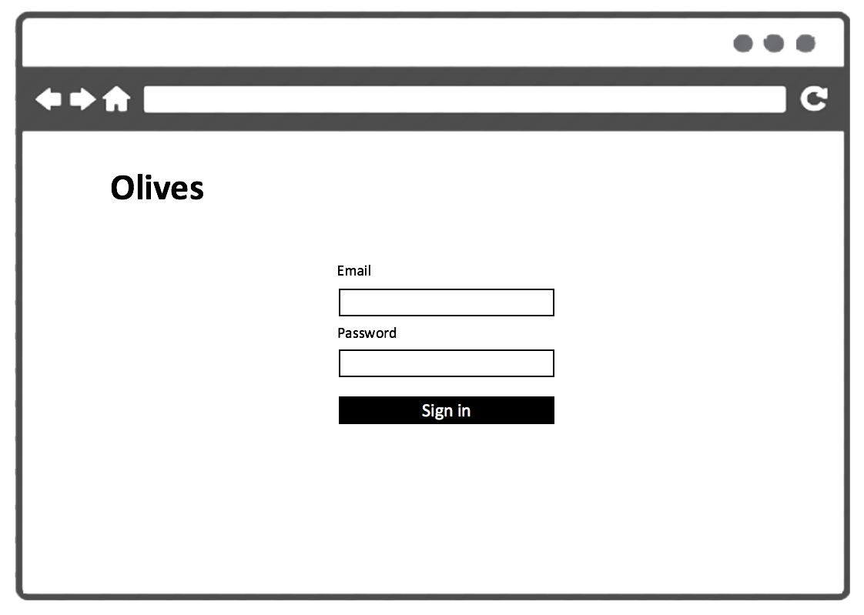

|  |  |  |
| --- | --- | --- |
| Element | Type | Description |
| Sign In | Button | Click to sign in |
| Email | Input Text | Text filed for entering name of user |
| Password | Input Text | Text firld for entering password of user |

## 2.1.2 Request Adminstration Screen

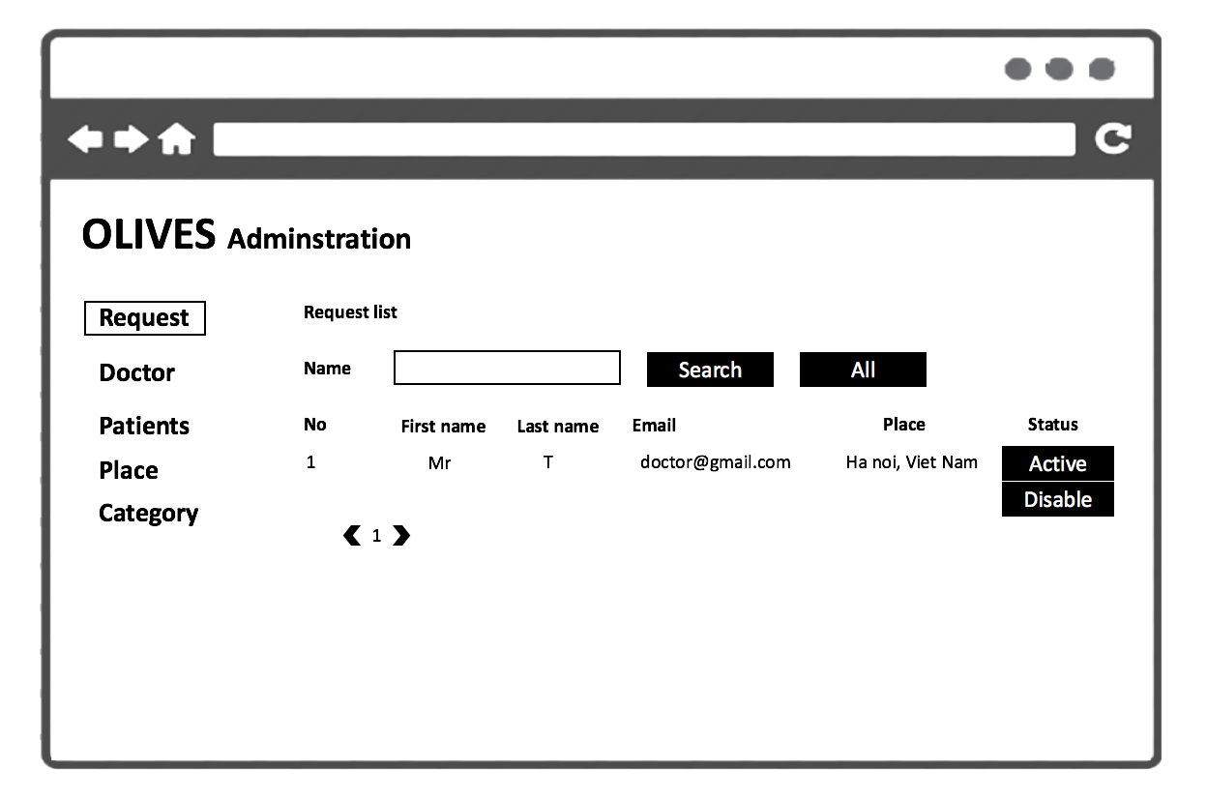

|  |  |  |
| --- | --- | --- |
| Element | Type | Description |
| Request list | Scroll View | Scroll down to view more request. |
| Disable | Button | Click to disable account |
| Name | Input Text | Text filed search name of user |
| Active | Button | Click to active acount |
| Search | Button | Click to search account for name |
| All | Button | Click ti show all account |

## 2.1.3 Doctor Adminstration Screen

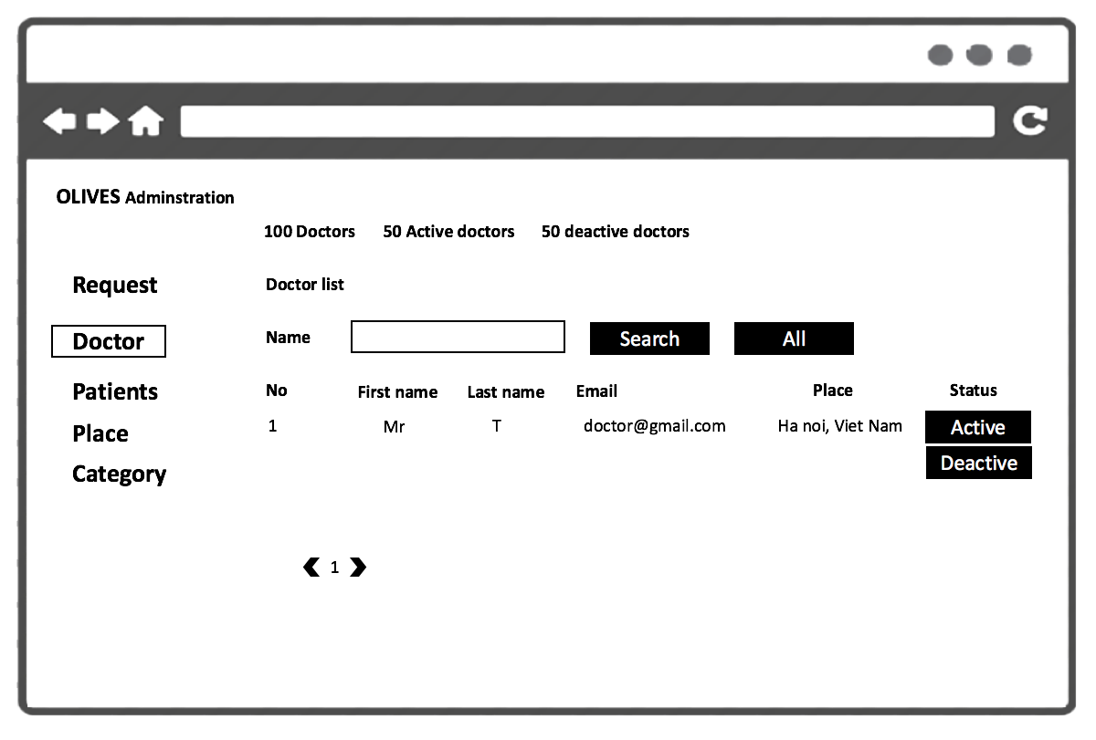

|  |  |  |
| --- | --- | --- |
| Element | Type | Description |
| Doctor list | Scroll View | Scroll down to view more doctor. |
| Disable | Button | Click to disable account of doctor |
| Name | Input Text | Text filed search name of doctor |
| Active | Button | Click to active acount of doctor |
| Search | Button | Click to search account doctor for name |
| All | Button | Click ti show all account of doctor |

## 2.1.4 Patients Adminstration Screen

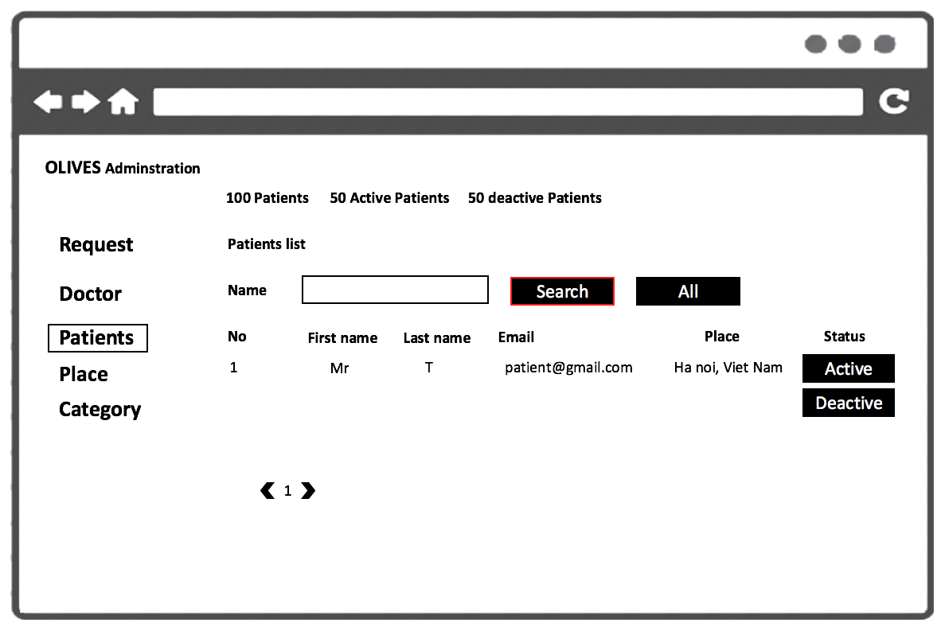

|  |  |  |
| --- | --- | --- |
| Element | Type | Description |
| Patients list | Scroll View | Scroll down to view more patients. |
| Disable | Button | Click to disable account of patient |
| Name | Input Text | Text filed search name of patient |
| Active | Button | Click to active acount of patient |
| Search | Button | Click to search account patient for name |
| All | Button | Click ti show all account of patient |

## 2.1.5 Palce Adminstration Screen

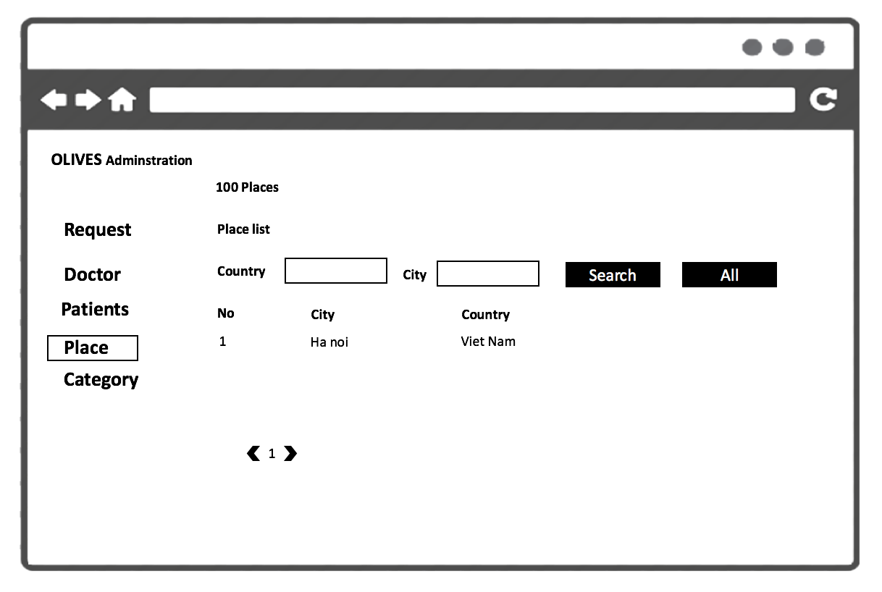

|  |  |  |
| --- | --- | --- |
| Element | Type | Description |
| Place list | Scroll View | Scroll down to view more place. |
| Country | Input Text | Text filed search country |
| City | Input Text | Text filed search city |
| Search | Button | Click to search account patient for name |
| All | Button | Click ti show all account of patient |

## 2.1.6 Category Adminstration Screen

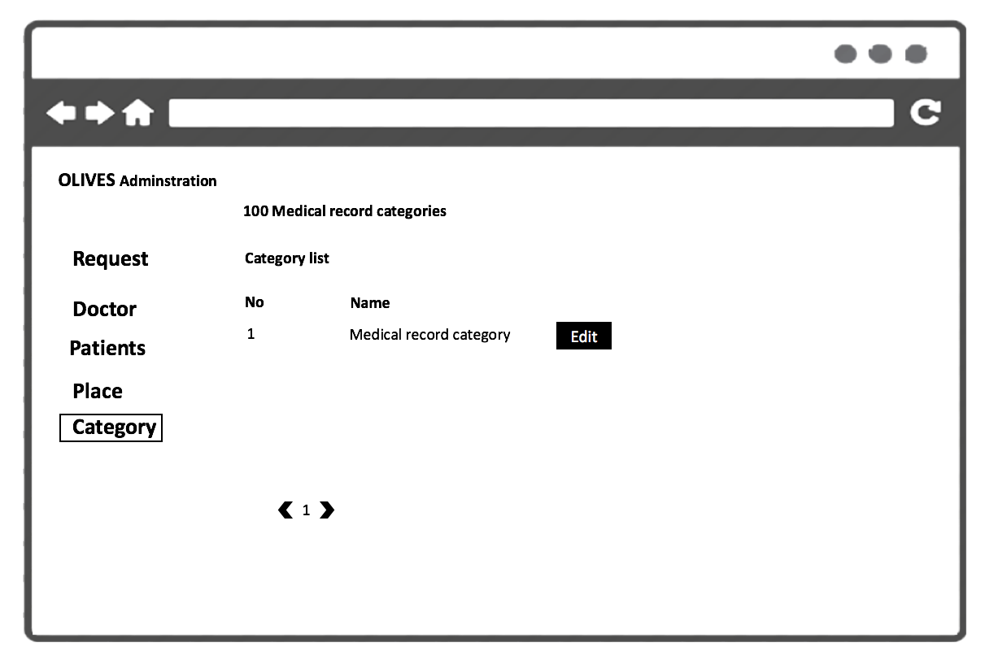

|  |  |  |
| --- | --- | --- |
| Element | Type | Description |
| Category list | Scroll View | Scroll down to view more category of medical record. |
| Edit | Button | Click to edit category |

## 2.1.7 Edit Category Screen

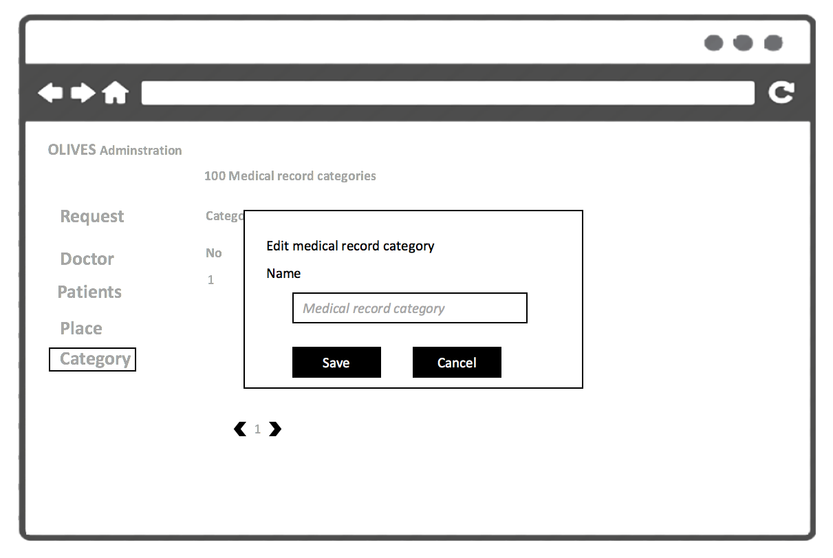

|  |  |  |
| --- | --- | --- |
| Element | Type | Description |
| Name | Input Text | Text Field for entering name of category . |
| Save | Button | Click to save category |
| Cancel | Button | Click to cancel |

## 2.1.8 Add Category Screen

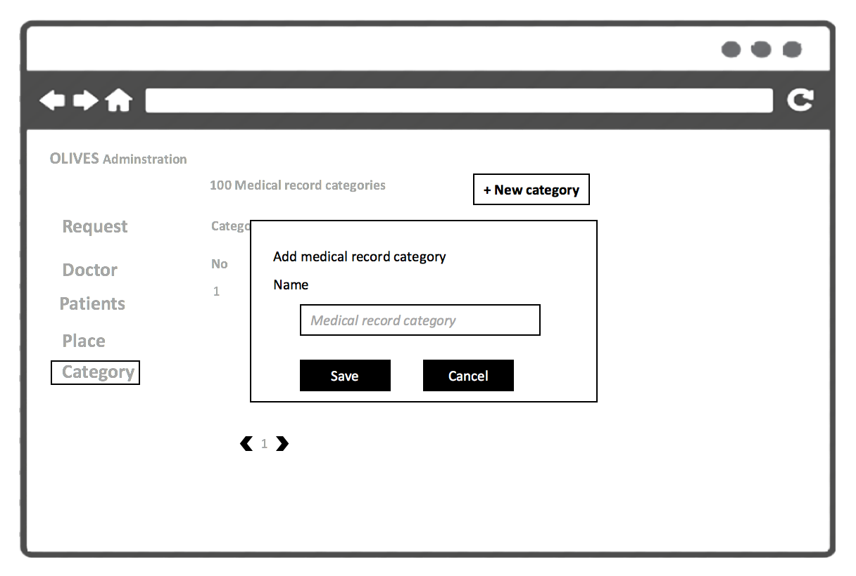

|  |  |  |
| --- | --- | --- |
| Element | Type | Description |
| Name | Input Text | Text Field for entering name of category . |
| Save | Button | Click to save category |
| Cancel | Button | Click to cancel |

## 2.1.9 Add Place Screen

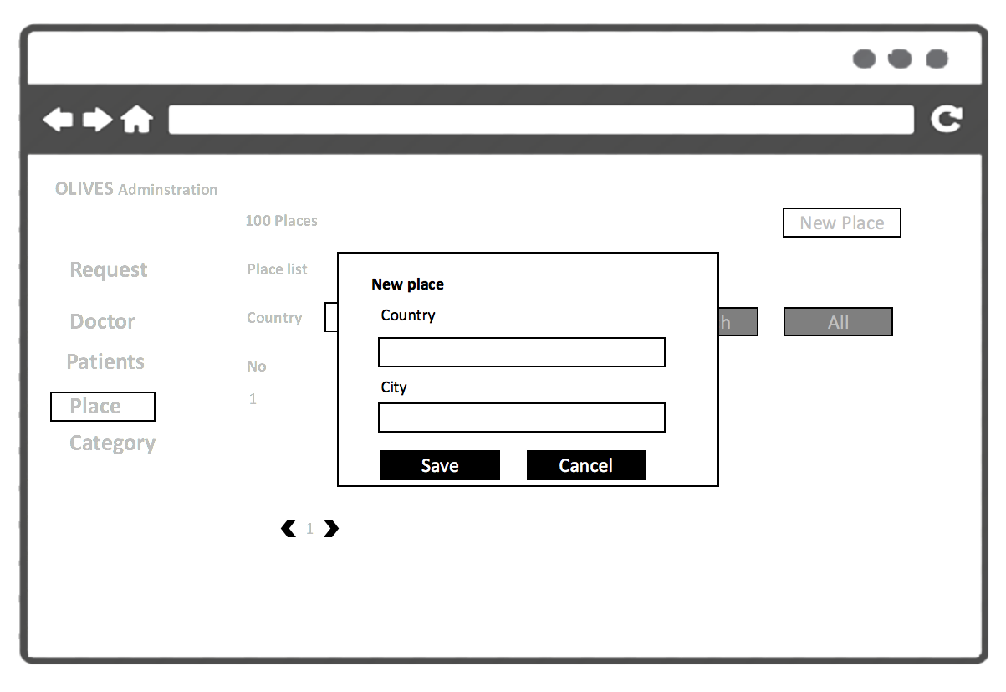

|  |  |  |
| --- | --- | --- |
| Element | Type | Description |
| Country | Input Text | Text Field for entering name of country . |
| City | Input Text | Text Field for entering name of city . |
| Save | Button | Click to save palce |
| Cancel | Button | Click to cancel |

## 2.1.10 Edit Place Screen

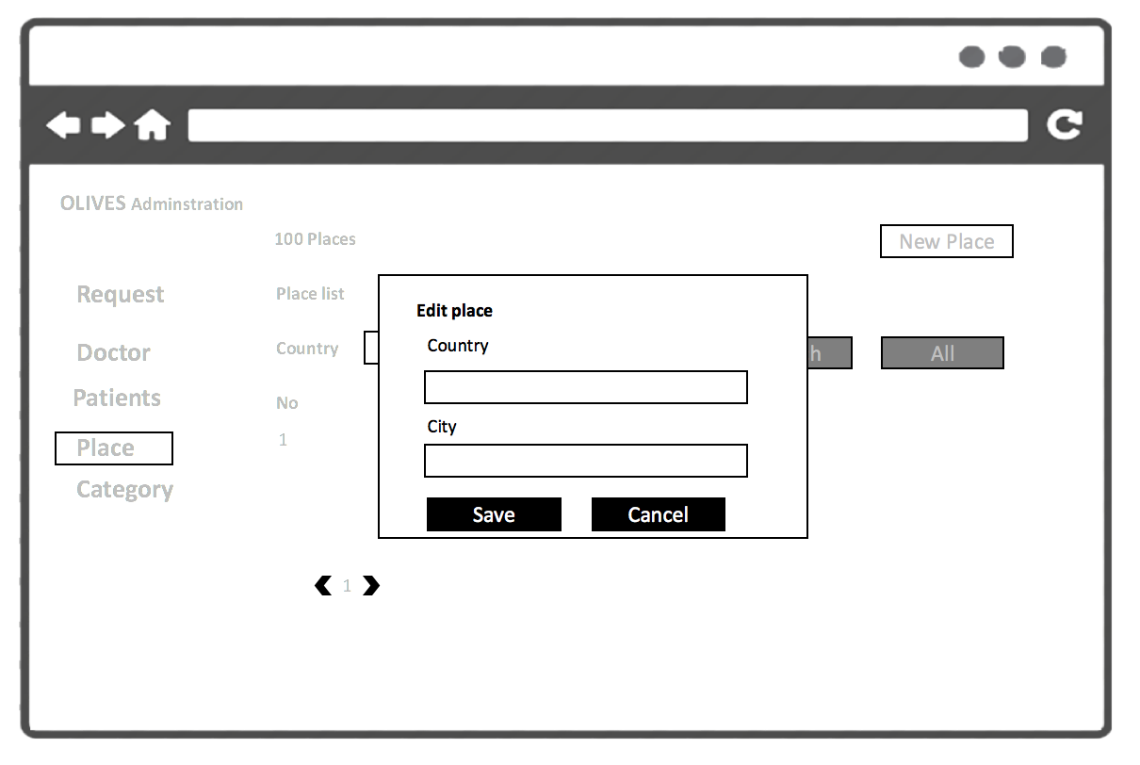

|  |  |  |
| --- | --- | --- |
| Element | Type | Description |
| Country | Input Text | Text Field for edit name of country . |
| City | Input Text | Text Field for edit name of city . |
| Save | Button | Click to save palce |
| Cancel | Button | Click to cancel |